Iot Home Assistant Device

ABSTRACT
With the rapid growth of smart home technologies, there is an increasing demand for systems that provide remote control, automation, and energy efficiency. This project presents an IoT Home Assistant Device using NodeMCU (ESP8266) and the Blynk IoT platform, designed to control household electrical appliances such as an air conditioner (AC) through a mobile dashboard.
The NodeMCU connects to the internet via Wi-Fi and communicates with the Blynk cloud. Using the Blynk mobile dashboard, users can remotely turn the AC device ON or OFF and monitor its operating status in real time. The system uses a relay module to safely interface the low-voltage controller with high-voltage AC appliances. This solution provides convenience, energy savings, and improved home automation at low cost.

CHAPTER 1

LITERATURE SURVEY

"IoT Based Smart Home Automation System"

Ramesh Kumar, Anil Singh

This paper presents a smart home automation system using NodeMCU and IoT platforms to control appliances. The system allows users to remotely operate devices via mobile applications. The authors emphasize its cost-effectiveness, scalability, and role in improving energy efficiency in residential environments.

"Remote Appliance Control Using NodeMCU and Blynk"

Priya Sharma, Neha Gupta
The study proposes an IoT-based system for remote appliance control using NodeMCU and the Blynk platform. Appliances such as fans and ACs are controlled via mobile dashboards. The authors highlight its convenience, low cost, and adaptability for smart homes. The system is tested in real-time scenarios and proves effective.

"IoT Enabled Home Assistant Device"

S. Patel, R. Mehta
This research integrates IoT with home assistant devices using ESP8266 and relay modules. The system provides real-time monitoring and control of appliances through mobile applications. The authors demonstrate its scalability for multiple devices and emphasize its role in enhancing user comfort and energy savings.

"Cloud Integrated Smart Home Monitoring"

Alok Jadhav, Vrishali Desai
The paper focuses on cloud integration for smart home monitoring systems. Sensor and appliance data are transmitted to cloud servers for storage and analysis. The system enables remote monitoring and predictive control. The authors highlight its importance in smart city initiatives and sustainable living.

"IoT Based Appliance Control Using ESP8266"

Rakshita MB, Siddharth Sharma
This study presents an IoT-based appliance control system using ESP8266 microcontroller and relay modules. The system allows users to control appliances remotely via mobile applications. The authors emphasize its role in reducing energy wastage and improving convenience. The solution is tested in residential settings and proves reliable.

CHAPTER 2
OBJECTIVES
The primary objective of the IoT Home Assistant Device is to design and develop a smart home automation system using the NodeMCU microcontroller that allows remote control of household appliances. The system aims to improve convenience, energy efficiency, and user comfort by enabling real-time monitoring and operation of electrical devices such as air conditioners (AC).
Another key objective is to integrate the system with the Blynk IoT platform, allowing users to control appliances via a mobile dashboard. The project also aims to use a relay module to safely interface the low-voltage NodeMCU with high-voltage AC appliances, ensuring safe operation.
Overall, the objectives are to provide a cost-effective, reliable, and user-friendly home automation solution that enhances energy management and remote accessibility of household devices.

METHODOLOGY
The methodology of the proposed system begins with hardware integration and configuration. The NodeMCU acts as the central control unit. A relay module is connected to the NodeMCU to safely switch the AC device ON or OFF. The microcontroller is powered using a regulated supply and connected to a Wi-Fi network for internet connectivity.
In the data acquisition and control phase, the NodeMCU communicates with the Blynk cloud server. The mobile dashboard allows users to send commands to the NodeMCU to turn the AC ON or OFF and monitor its operating status in real time. The relay module receives control signals from the NodeMCU to actuate the high-voltage appliance safely.
During operation, the NodeMCU continuously monitors the appliance status and updates the Blynk dashboard with real-time information. The system ensures that the user can remotely manage the appliance, reducing unnecessary energy consumption and improving home automation efficiency.
Finally, the system is tested under different scenarios to verify the accuracy of remote control, relay operation, and real-time status updates. The response time between mobile commands and appliance action is evaluated to ensure reliability. Through continuous monitoring, safe appliance control, and IoT connectivity, the Home Assistant Device provides an efficient, convenient, and cost-effective solution for smart home automation.

BLOCK DIAGRAM
NodeMCU
Micro Controller
Relay
AC Devices

CHAPTER 3
HARDWARE REQUIREMENTS

Node MCU
Technically speaking NodeMCU is a firmware for ESP8266 developed using C Programming Language, Espressif NON-OS SDK and Lua scripting language. Traditionally, we write code for our Microcontrollers like Arduino, STM32, 8051 etc., either in C or C++ and compile it with a set of tools and generate a binary file. This binary file is then uploaded into the flash memory of the microcontroller and it gets executed. Things are quite different with NodeMCU. You can consider the NodeMCU firmware as an interpreter for Lua Scripts. So, if your ESP8266 is loaded with NodeMCU Firmware, you can simply write your application in Lua and send it to the ESP8266.NodeMCU Firmware will interpret the byte code and executes the commands. There is no compilation, no binary file etc. Just write a script and run it the team which developed NodeMCU Firmware also developed a breakout board for ESP-12E module called the NodeMCU Devkit. So, many of us are actually using the board called NodeMCU and programming it with Arduino IDE and not the Lua Scripts.
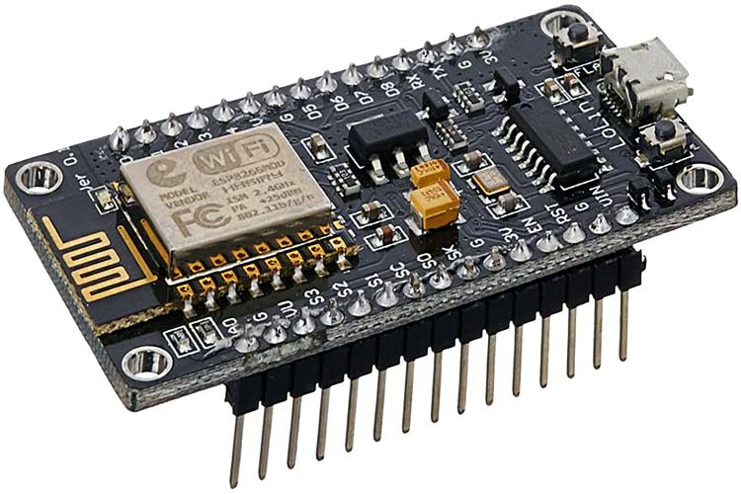
IMPORTANT NOTE: Only one firmware can exist on the ESP8266. It can be either AT Commands Firmware, NodeMCU Firmware or Arduino based code. Once you upload an Arduino sketch, the NodeMCU firmware gets erased. If you want to work with Lua Scripts and NodeMCU, then you have to flash the NodeMCU Firmware.
ESP-01 vs. NodeMCU (ESP-12E)
As mentioned earlier, the NodeMCU Devkit is actually a Breakout Board for the ESP-12E Module. The ESP-01 is the vanilla version of the ESP8266 Wi-Fi SoC made by Ai–Thinker, a third part module manufacturer for ESP8266.

Brief about NodeMCU ESP8266
The NodeMCU ESP8266 development board comes with the ESP-12E module containing the ESP8266 chip having Tensilica Xtensa 32-bit LX106 RISC microprocessor. This microprocessor supports RTOS and operates at 80MHz to 160 MHz adjustable clock frequency. NodeMCU has 128 KB RAM and 4MB of Flash memory to store data and programs. Its high processing power with in-built Wi-Fi / Bluetooth and Deep Sleep Operating features make it ideal for IoT projects.
NodeMCU can be powered using a Micro USB jack and VIN pin (External Supply Pin). It supports UART, SPI, and I2C interface.
- ESP8266 Chip: The core of the NodeMCU module is the ESP8266 chip, which provides Wi-Fi connectivity and microcontroller functionality.

- GPIO Pins: The NodeMCU board includes multiple digital and analog pins that can be used to connect various peripherals such as sensors, LEDs, and motors.

- Serial Communication Protocols: It supports UART, SPI, and I2C protocols, enabling communication with other devices and modules.

- Open-Source Firmware: The NodeMCU firmware is open-source and based on the Lua scripting language, making it easy to program and customize.
•Compact Design: The NodeMCU module is small and lightweight, making it suitable for various applications, from hobby projects to professional IoT solutions

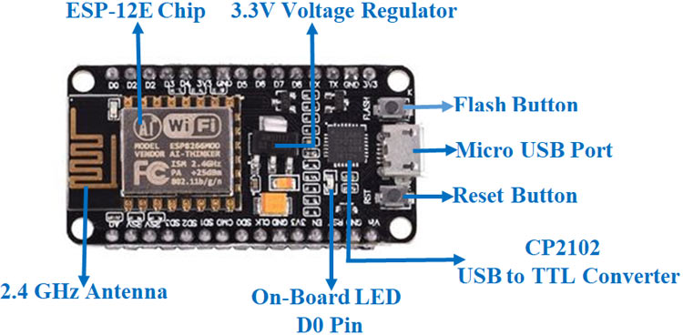

ESP8266 Wi-Fi module
ESP8266 comes up with powerful processing speed on board. Storage space of this module is also high allowing it to integrate with other devices like sensors. To make this module compatible with other development boards, we have to do level shifting of voltages externally because this board doesn’t come up with on-board voltage regulator. This module is cost effective and thus used widely in many applications like the Internet of things and much more. So in this article, we are going to discuss key features of ESP8266, pins specifications, how to use this board for programming purposes and a sample program.
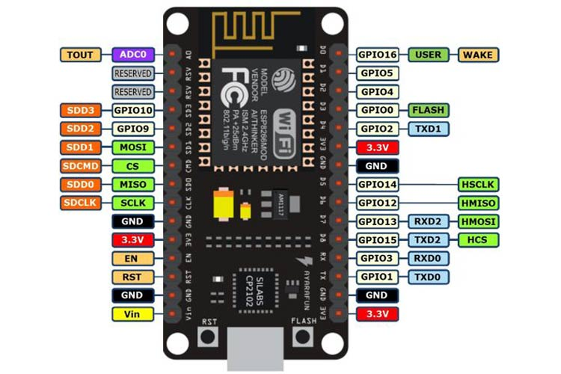

NodeMCU ESP8266 Specifications & Features
The Node MCU module is built around the powerful ESP8266 microcontroller, which is well-suited for IoT applications due to its integrated Wi-Fi capabilities and robust processing power. Here’s a detailed look at its specifications:
Microcontroller: Tensilica 32-bit RISC CPU Xtensa LX106
The core of the NodeMCU is the Tensilica Xtensa LX106, a 32-bit RISC CPU known for its efficiency and performance in handling complex tasks with low power consumption.
Operating Voltage: 3.3V
The module operates at a standard 3.3V, making it compatible with a wide range of sensors and peripherals that also use 3.3V logic levels.
Input Voltage: 7-12V
It accepts an input voltage range of 7-12V, which is regulated down to 3.3V by the onboard regulator, ensuring stable operation and protecting the microcontroller from voltage fluctuations.
Digital I/O Pins (DIO): 16
The NodeMCU provides 16 digital input/output pins that can be used to interface with various sensors, actuators, and other digital devices. These pins can be programmed for general purpose use, such as reading sensor data or controlling LEDs.
Analog Input Pin (ADC): 1
There is one analog input pin available, allowing for the connection of analog sensors. This pin can read voltage levels and convert them into digital values for processing.
UARTs: 1
The module includes one UART (Universal Asynchronous Receiver/Transmitter) for serial communication, which is essential for debugging and connecting to other serial devices.
SPIs: 1
One SPI (Serial Peripheral Interface) is available, providing high-speed communication with devices like SD cards, displays, and other SPI peripherals.
I2Cs: 1
The I2C (Inter-Integrated Circuit) bus allows for communication with multiple I2C devices using only two wires, making it ideal for connecting sensors and modules that support I2C communication.
Flash Memory: 4 MB
The NodeMCU is equipped with 4 MB of flash memory for storing the firmware and user programs. This ample storage space allows for the development of complex applications and features.
SRAM: 64 KB
It includes 64 KB of SRAM (Static Random Access Memory) for data storage and processing during runtime. This memory is used for variables, data buffers, and program execution.
Clock Speed: 80 MHz
The microcontroller operates at a clock speed of 80 MHz, providing sufficient processing power for handling various tasks efficiently and in real-time.
USB-TTL based on CP2102:
The onboard CP2102 USB-to-TTL converter allows for easy programming and serial communication over USB. It enables plug-and-play functionality, simplifying the setup and development process.
PCB Antenna:
The NodeMCU features an integrated PCB antenna, which provides reliable Wi-Fi connectivity without the need for an external antenna. This design keeps the module compact and easy to use.
Compact Size:
The small form factor of the NodeMCU module makes it ideal for integration into IoT projects, where space is often limited. Its compact size allows it to fit seamlessly into a wide range of applications, from home automation to wearable devices.

Installation Steps
Now, to install the NODE MCU board in the Arduino IDE, you need to follow the below steps −
- Make sure you have Arduino IDE (preferably the latest version) installed on your machine
- Open Arduino and go to File −> Preferences
- In the Additional Boards Manager URL, enter
https://dl.espressif.com/dl/package_ESP8266_index.json
In case you have an existing JSON file's URL in the preferences (this is likely if you've installed ESP8266, stm32duino, or any such additional board in the IDE), you can just append the above path to the existing path, using a comma. An example is shown below, for ESP8266 and NODE MCU boards −
http://arduino.esp8266.com/stable/package_esp8266com_index.json, https://dl.espressif.com/dl/package_ESP8266_index.json
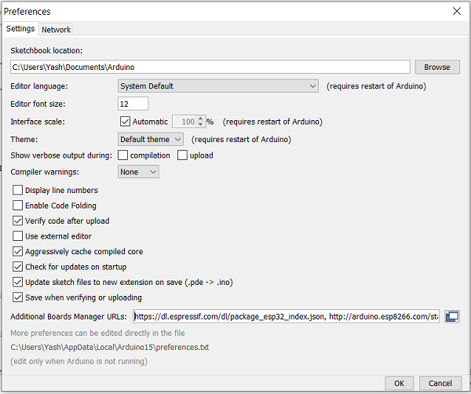
Go to Tools −> Board−> Boards Manager. A pop−up would open up. Search for ESP8266and install the ESP8266by Espressif Systems board. The image below shows the board already installed because I had installed the board before preparing this tutorial.
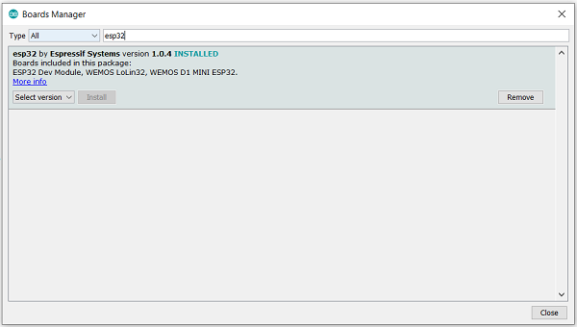

Verifying the Installation
Once your ESP8266board has been installed, you can verify the installation by going to Tools −> Boards. You can see a whole bunch of boards under the ESP8266Arduino section. Choose the board of your choice. If you are not sure which board best represents the one you have, you can choose ESP8266Module.
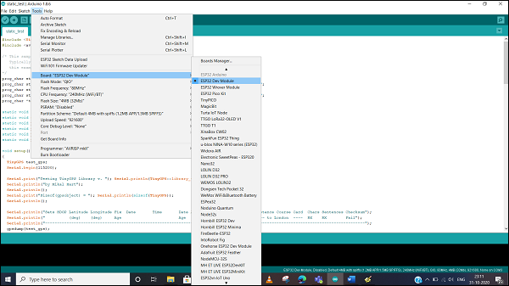
Next, connect your board to your machine using the USB Cable. You should see an additional COM Port under Tools−> Port. Select that additional port. In case you see multiple ports, you can disconnect the USB and see which port disappeared. That port corresponds to ESP8266.
Once the port is identified, pick any one example sketch from File −> Examples. We will choose the Start Counter example from File −> Examples −> Preferences −> Start Counter.
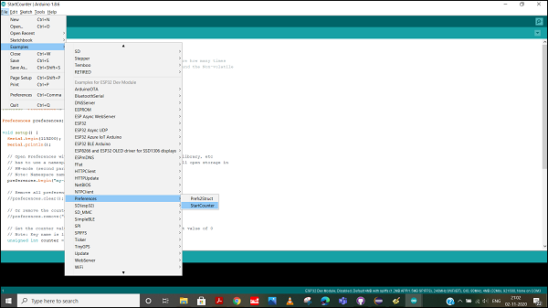
Open that sketch, compile it and flash it into the ESP8266by clicking on the Upload button (the right arrow button, besides the Compile button).
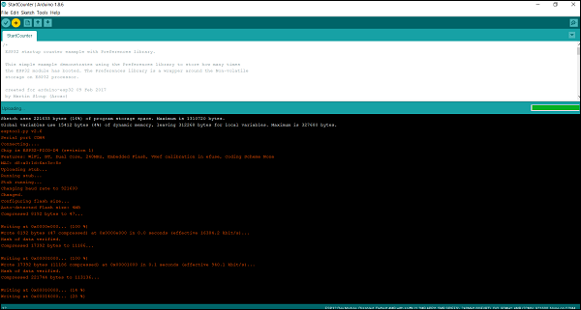
Then open the Serial Monitor using Tools −> Serial Monitor, or simply by pressing Ctrl + Shift + M on your keyboard. You should see the counter value getting incremented after every ESP8266restart.

RELAY

A Relay is a simple electromechanical switch. While we use normal switches to close or open a circuit manually, a Relay is also a switch that connects or disconnects two circuits. But instead of a manual operation, a relay uses an electrical signal to control an electromagnet, which in turn connects or disconnects another circuit.
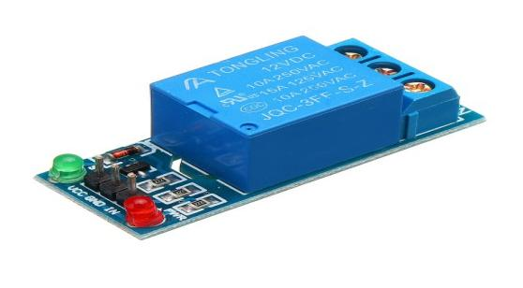
Relays can be of different types like electromechanical, solid state. Electromechanical relays are frequently used. Let us see the internal parts of this relay before knowing about working of relay. Although many different types of relay were present, their working is same.
Every electromechanical relay consists of an consists of an
- Electromagnet
- Mechanically movable contact
- Switching points and
- Spring
Electromagnet is constructed by wounding a copper coil on a metal core. The two ends of the coil are connected to two pins of the relay as shown. These two are used as DC supply pins.
How to connect relay module with Arduino
As shown in relay working idea it depends on magnetic field generated from the coil so there is power isolation between the coil and the switching pins so coils can be easily powered from Arduino by connecting VCC and GND bins from Arduino kit to the relay module kit after that we choose Arduino output pins depending on the number of relays needed in project designed and set these pins to output and make it out high (5 V) to control the coil that allow controlling of switching process

Pin Configuration

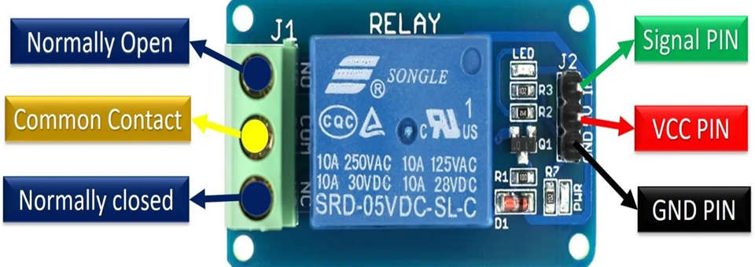
Pin Configuration : 5V Relay Module
SIGNAL PIN – It is a control pin. This signal will energize the relay coil to make contact with the common terminal with the normally open terminal. This pin can be active low or active high.
VCC PIN – That means it requires 5V DC to operate. Hence, connect the 5v DC power supply to this pin.
GND PIN – connected to ground.
COMMON PIN- This terminal is connected with the load that we want to switch with the relay module.
NC PIN – It is normally connected with the COM pin and forms a closed circuit. But this normally closed connection breaks when the relay is activated by applying an active high or active low signal.
NO PIN – This pin is normally open unless we apply an activation signal to the signal pin of the 5V single channel relay. when the relay gets activated common pin disconnects the NC pin and connects to the NO pin.
Internal circuit:
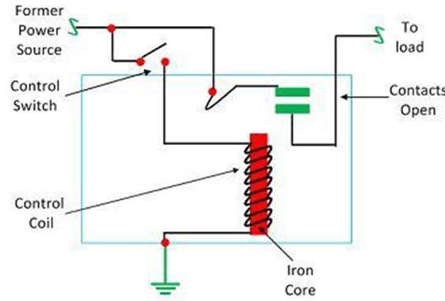
Internal Circuit : 5V Relay Module
- It works on the principle of electromagnetic attraction. When the circuit of the relay senses the fault current, it energizes the electromagnetic field which produces the temporary magnetic field.
- The inner section of the relay has an iron core which is wound by a control coil. The power supply is given to the coil through the contacts of the load and the control switch. The current flows through the coil and produces the magnetic field around it.
- Due to this magnetic field, the upper arm of the magnet attracts the lower arm. Hence close the circuit, which makes the current flow through the load. If the contact is already closed, then it moves oppositely and hence opens the contacts.

AC DEVICE
A light-bulb produces light from electricity.^{[1]} In addition to lighting a dark space, they can be used to show an electronic device is on, to direct traffic, for heat, and for many other purposes. Billions are in use, some even in outer space.
Early people used candles and oil lamps for light. Humphry Davy invented the electric arclight in the early 1800s. Thomas Alva Edison, Joseph Swann, and several others in the 1880s invented the more efficient incandescent lightbulb.
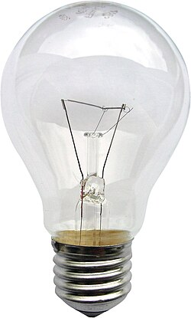

CHAPTER 4

SOFTWARE CONSTRAINTS

INTRODUCTION TO ARDUINO IDE

Arduino is a prototype platform (open-source) based on an easy-to-use hardware and software. It consists of a circuit board, which can be programmed (referred to as a microcontroller) and a ready-made software called Arduino IDE (Integrated Development Environment), which is used to write and upload the computer code to the physical board.

KEY FEATURES OF ARDUINOIDE
Arduino boards are able to read analog or digital input signals from different sensors and turn it into an output such as activating a motor, turning LED on/off, connect to the cloud and many other actions.
You can control your board functions by sending a set of instructions to the microcontroller on the board via Arduino IDE (referred to as uploading software).
Unlike most previous programmable circuit boards, Arduino does not need an extra piece of hardware (called a programmer) in order to load a new code onto the board. You can simply use a USBcable.
Additionally, the Arduino IDE uses a simplified version of C++, making it easier to learn to program.Finally, Arduino provides a standard form factor that breaks the functions of the micro-controller into a more accessible package.
After learning about the main parts of the Arduino UNO board, we are ready to learn how to set up the Arduino IDE. Once we learn this, we will be ready to upload our program onthe Arduino board.

ARDUINO DATATYPES
Data types in C refers to an extensive system used for declaring variables or functions of different types. The type of a variable determines how much space it occupies in the storage and how the bit pattern stored isinterpreted.
The following table provides all the data types that you will use During Arduino programming.

Void
The void keyword is used only in function declarations. It indicates that the function is expected to return no information to the function from which it was called.
Example:

Void Loop ( )

{

// rest of the code

}

Boolean
A Boolean holds one of two values, true or false. Each Boolean variable occupies one byte of memory.
Example:
Boolean state= false ; // declaration of variable with type boolean and initialize it withfalse.
Boolean state = true ; // declaration of variable with type boolean and initialize it withfalse.

Char
A data type that takes up one byte of memory that stores a character value. Character literals are written in single quotes like this: 'A' and for multiple characters, strings use double quotes: "ABC".
However, characters are stored as numbers. You can see the specific encoding in the ASCII chart. This means that it is possible to do arithmetic operations on characters, in whichthe ASCII value of the character is used. For example, 'A' + 1 has the value 66, since theASCII value of the capital letter A is65.

Example:
Char chr_a = ‘a’ ;//declaration of variable with type char and initialize it with character a.
Char chr_c = 97 ;//declaration of variable with type char and initialize it with character 97

Unsigned char
Unsigned char is an unsigned data type that occupies one byte of memory. The unsigned char data type encodes numbers from 0 to 255.

Example:
Unsigned Char chr_y = 121 ; // declaration of variable with type Unsigned char and initialize it with character y

Byte
A byte stores an 8-bit unsigned number, from 0 to 255. Example:
byte m = 25 ;//declaration of variable with type byte and initialize it with 25

int
Integers are the primary data-type for number storage. int stores a 16-bit (2-byte) value. This yields a range of -32,768 to 32,767 (minimum value of -2^15 and a maximum value of (2^15) - 1).
The intsize varies from board to board. On the Arduino Due, for example, an intstores a 32-bit (4-byte) value. This yields a range of -2,147,483,648 to 2,147,483,647 (minimum value of -2^31 and a maximum value of (2^31) - 1).

Example:
int counter = 32 ;// declaration of variable with type int and initialize it with 32.

Unsigned int
Unsigned int’s (unsigned integers) are the same as intin the way that they store a 2 byte value. Instead of storing negative numbers, however, they only store positive values, yielding a useful range of 0 to 65,535 (2^16) - 1). The Due stores a 4 byte (32-bit) value, ranging from 0 to 4,294,967,295 (2^32 -1).

Example:
Unsigned int counter= 60 ; // declaration of variable with type unsigned int and initialize it with 60.

Word
On the Uno and other ATMEGA based boards, a word stores a 16-bit unsigned number. On the Due and Zero, it stores a 32-bit unsigned number.

Example:
word w = 1000 ;//declaration of variable with type word and initialize itwith 1000.

Long Long variables are extended size variables for number storage, and store 32 bits (4 bytes), from 2,147,483,648 to 2,147,483,647.

Example:
Long velocity= 102346 ;//declaration of variable with type Long and initialize it with 102346

Unsigned long
Unsigned long variables are extended size variables for number storage and store 32 bits (4 bytes). Unlike standard longs, unsigned longs will not store negative numbers, making their range from 0 to 4,294,967,295 (2^32 - 1).
Example:
Unsigned Long velocity = 101006 ;// declaration of variable with type Unsigned Long and initialize it with 101006.

Short
A short is a 16-bit data-type. On all Arduinos (ATMega and ARM based), a short stores a 16-bit (2-byte) value. This yields a range of -32,768 to 32,767 (minimum value of -2^15 and a maximum value of (2^15) -1).
Example:
shortval= 13 ;//declaration of variable with type short and initialize it with 13

Float
Data type for floating-point number is a number that has a decimal point. Floating-point numbers are often used to approximate the analog and continuous values because they have greater resolution than integers.
Floating-point numbers can be as large as 3.4028235E+38 and as low as 3.4028235E+38. They are stored as 32 bits (4 bytes) of information.
Example:
floatnum = 1.352;//declaration of variable with type float and initialize it with
1.352.

Double
On the Uno and other ATMEGA based boards, Double precision floating-point number occupies four bytes. That is, the double implementation is exactly the same as the float, with no gain in precision. On the Arduino Due, doubles have 8-byte (64 bit) precision
Example:
doublenum = 45.352 ;// declaration of variable with type double and initialize it with 45.352.

STEPS TO UPLOAD THE PROGRAM IN ARDUINOBOARD

In this section, we will learn in easy steps, how to set up the Arduino IDE on our computer and prepare the board to receive the program via USB cable.

Step 1: First you must have your Arduino board (you can choose your favorite board) anda USB cable.
In case you use Arduino UNO, Arduino Duemilanove, Nano, Arduino Mega2560, or Diecimila, you will need a standard USB cable (A plug to B plug), the kind youwould connect to a USB printer as shown in the following image.
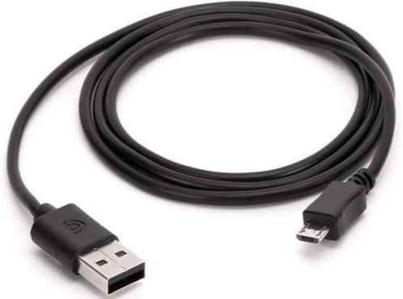

Fig 4.1 USB Cable

Step 2: Download Arduino IDE Software.

You can get different versions of Arduino IDE from the Download page on the Arduino Official website. You must select your software, which is compatible with your operating system (Windows, IOS, or Linux). After your file download is complete, unzip the file.
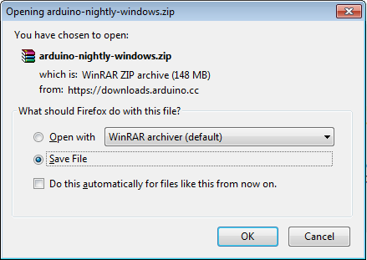

Step 3: Power up your board.

The Arduino Uno, Mega, Duemilanove and Arduino Nano automatically draw power from either, the USB connection to the computer or an external power supply. If you are using an Arduino Diecimila, you have to make sure that the board is configured todrawpowerfromtheUSBconnection.Thepowersourceisselectedwithajumper,a
small piece of plastic that fits onto two of the three pins between the USB and power jacks. Check that it is on the two pins closest to the USB port. Connect the Arduino board to your computer using the USB cable. The green power LED (labeled PWR) should glow.
Step 4: Launch Arduino IDE.
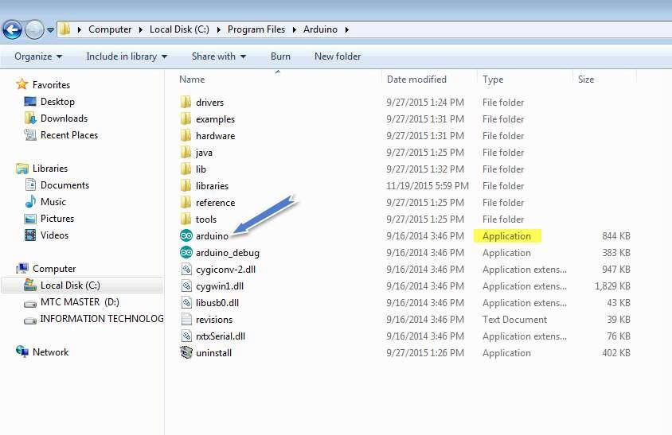
After your Arduino IDE software is downloaded, you need to unzip the folder. Inside the folder, you can find the application icon with an infinity label (application.exe). Doubleclick the icon to start theIDE.

Step 5: Open your first project.
Once the software starts, you have two options: Create a new project.
Open an existing project example.
To create a new project, select File -->New.To open
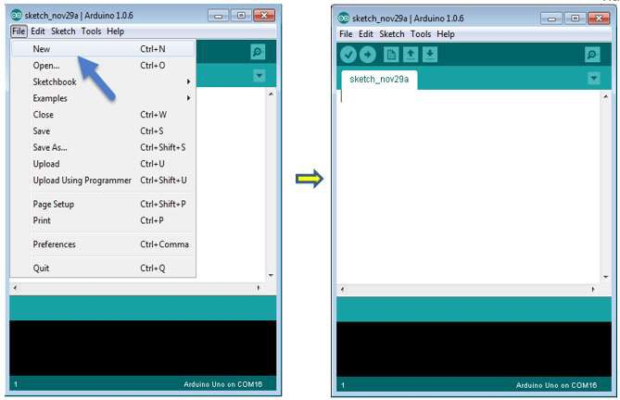

To open an existing project example, select File -> Example -> Basics -> Blink.
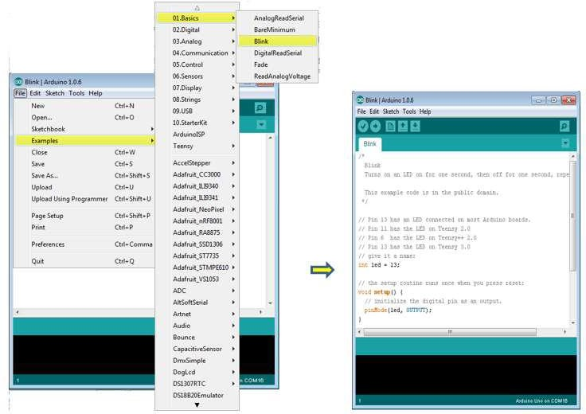

Here, we are selecting just one of the examples with the name Blink. It turns the LED on and off with some time delay. You can select any other example from the list.

Step 6: Select your Arduino board.
To avoid any error while uploading your program to the board, you must select the correct Arduino board name, which matches with the board connected to your computer.
Go to Tools -> Board and select your board

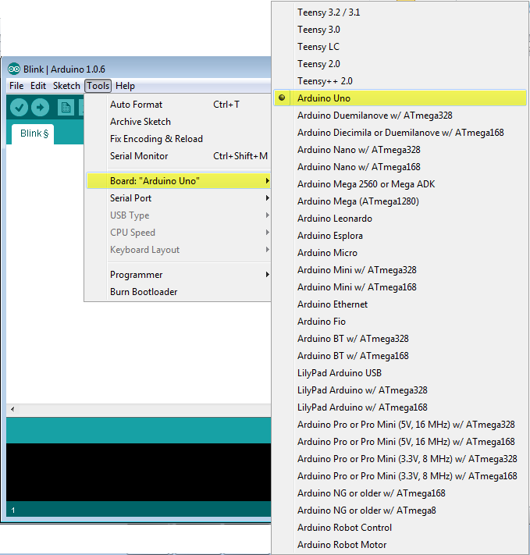

Here, we have selected Arduino Uno board according to our tutorial, but you must select the name matching the board that you are using
Step 7: Select your serial port.
Select the serial device of the Arduino board. Go to Tools ->Serial Port menu. This is likely to be COM3 or higher (COM1 and COM2 are usually reserved for hardware serial ports). To find out, you can disconnect your Arduino board and re-open the menu, the entry that disappears should be of the Arduino board. Reconnect the board and select that serialport.

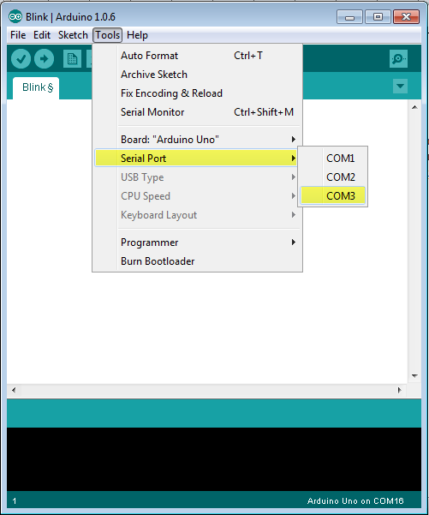

Step 8: Upload the program to your board.
Before explaining how we can upload our program to the board, we mustdemonstrate the function of each symbol appearing in the Arduino IDE toolbar.
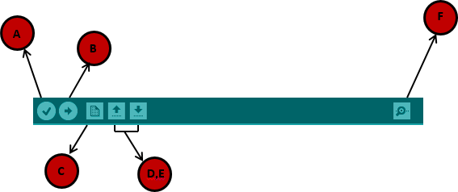

A- Used to check if there is any compilation error. B- Used to upload a program to the Arduino board.
C- Shortcut used to create a new sketch.
D- Used to directly open one of the example sketch. E- Used to save your sketch.
F- Serial monitor used to receive serial data from the board and send the serial data to theboard.
Now, simply click the "Upload" button in the environment. Wait a few seconds; you will see the RX and TX LEDs on the board, flashing. If the upload is successful, the message "Done uploading" will appear in the status bar.
Note: If you have an Arduino Mini, NG, or other board, you need to press the reset button physically on the board, immediately before clicking the upload button on the ArduinoSoftware.

ARDUINO PROGRAMMING STRUCTURE

In this chapter, we will study in depth, the Arduino program structure and we will learn more new terminologies used in the Arduino world. The Arduino software is open- source. The source code for the Java environment is released under the GPL and the C/C++ microcontroller libraries are under the LGPL.

Sketch: The first new terminology is the Arduino program called “sketch”. Structure
Arduino programs can be divided in three main parts: Structure, Values (variables and constants), and Functions. In this tutorial, we will learn about the Arduino software program, step by step, and how we can write the program without any syntax or compilation error.
Let us start with the Structure. Software structure consist of two main functions: Setup( ) function
Loop( ) function

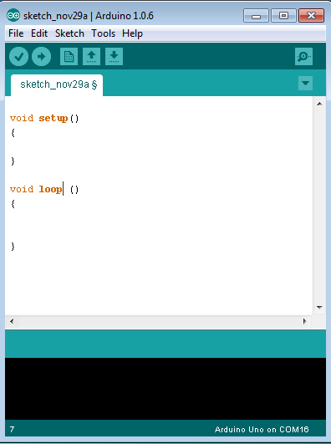

Void setup ( )
{
}

PURPOSE:
The setup() function is called when a sketch starts. Use it to initialize the variables, pin modes, start using libraries, etc. The setup function will only run once, after each power up or reset of the Arduinoboard.
INPUT
OUTPUT
RETURN

Void Loop ( )
{
}

PURPOSE:
After creating a setup() function, which initializes and sets the initial values, the loop() function does precisely what its name suggests, and loops secutively, allowing your program to change and respond. Use it to actively control the Arduinoboard.
INPUT
OUTPUT
RETURN

